FEYNN LABS_ PROJECT - 1_EXPLORATORY DATA ANALYSIS

Created by : Parth shukla

Now here I am given with project 1 under feynn labs Machine Learning Internship.

In this perticular project I have to come up with a business idea where I will apply Machine Learning/Data Science in small or medium business and help them with their sales, business operations, marketing etc.

So as a part of my this project I have found one sales dataset of one small shop on Kaggle and I will be using Machine Learning or Data Science techniques to help small buissnesses grow using this freely available dataset.

Let's Start

In the first step here we will be downloading the dataset ( CSV Format ) in our local computer and transferring that into desired file to load it here using Pandas library.

- Getting touch with our data

1. Importing Numpy and Pandas

In [1]: import pandas as pd

import numpy as np

2. Defining our dataset "df" , and loading our csv file into that.

In [2]: df = pd.read_csv('Data/201904 sales reciepts.csv')

3. Exploring our dataset first time.

Having first look of our dataset using df.head().

In [3]: df.head()

Out[3]:

 |  |  | transaction_id | transaction_date | transaction_time | sales_outlet_id | staff_id | customer_id instore_yn order |  |  | line_item_id |  | product_id | quantity line
 | 0 |  | 7 | 2019-04-01 | 12:04:43 | 3 | 12 | 558 | N | 1 | 1 |  | 52 | 1
 | 1 |  | 11 | 2019-04-01 | 15:54:39 | 3 | 17 | 781 | N | 1 | 1 |  | 27 | 2
 | 2 |  | 19 | 2019-04-01 | 14:34:59 | 3 | 17 | 788 | Y | 1 | 1 |  | 46 | 2
 | 3 |  | 32 | 2019-04-01 | 16:06:04 | 3 | 12 | 683 | N | 1 | 1 |  | 23 | 2
 | 4 |  | 33 | 2019-04-01 | 19:18:37 | 3 | 17 | 99 | Y | 1 | 1 |  | 34 | 1

Checking for datatypes of all indivisual columns of our dataset using df.info().
In [4]: df.info()
<class 'pandas.core.frame.DataFrame'>
RangeIndex: 49894 entries, 0 to 49893
Data | columns (total 14 | columns):
# | Column | Non-Null Count |  | Dtype
--- | ------ | -------------- |  | -----
0 | transaction_id | 49894 | non-null | int64
1 | transaction_date | 49894 | non-null | object
2 | transaction_time | 49894 | non-null | object
3 | sales_outlet_id | 49894 | non-null | int64
4 | staff_id | 49894 | non-null | int64
5 | customer_id | 49894 | non-null | int64
6 | instore_yn | 49894 | non-null | object
7 | order | 49894 | non-null | int64
8 | line_item_id | 49894 | non-null | int64
9 | product_id | 49894 | non-null | int64
10 | quantity | 49894 | non-null | int64
11 | line_item_amount | 49894 | non-null | float64
12 | unit_price | 49894 | non-null | float64
13 | promo_item_yn | 49894 | non-null | object
dtypes: float64(2), int64(8), object(4)

memory usage: 5.3+ MB

checking for some mathematical relations and behaviours of our dataset using df.describe().
In [5]: df.describe()

Out[5]:

 | transaction_id | sales_outlet_id | staff_id customer_id |  | order | line_item_id | product_id | quantity | line_item_amount | un
count | 49894.000000 | 49894.000000 | 49894.000000 | 49894.000000 | 49894.000000 | 49894.000000 | 49894.000000 | 49894.000000 | 49894.000000 | 49894
mean | 869.056059 | 5.351846 | 25.359582 | 2282.324468 | 1.173428 | 1.631860 | 47.878983 | 1.438209 | 4.682646 | 3
std | 857.863149 | 2.074796 | 12.466490 | 3240.551757 | 1.025445 | 1.412881 | 17.928355 | 0.543039 | 4.436668 | 2
min | 1.000000 | 3.000000 | 6.000000 | 0.000000 | 1.000000 | 1.000000 | 1.000000 | 1.000000 | 0.000000 | 0
25% | 223.000000 | 3.000000 | 15.000000 | 0.000000 | 1.000000 | 1.000000 | 33.000000 | 1.000000 | 3.000000 | 2
50% | 481.000000 | 5.000000 | 26.000000 | 0.000000 | 1.000000 | 1.000000 | 47.000000 | 1.000000 | 3.750000 | 3
75% | 1401.000000 | 8.000000 | 41.000000 | 5412.000000 | 1.000000 | 1.000000 | 60.000000 | 2.000000 | 6.000000 | 3
max | 4203.000000 | 8.000000 | 45.000000 | 8501.000000 | 9.000000 | 12.000000 | 87.000000 | 8.000000 | 360.000000 | 45

5. Checking for corelations in our dataset.

Going ahead , using df.corr() to get the correlations of every column with all other columns in our dataset.
In [6]: df.corr()

Out[6]:

 | transaction_id | sales_outlet_id | staff_id | customer_id | order | line_item_id | product_id | quantity | line_item_amount | unit_price
transaction_id | 1.000000 | -0.134200 | -0.050462 | 0.004820 | -0.052610 | -0.047631 | -0.046251 | 0.015083 | -0.010319 | -0.033934
sales_outlet_id | -0.134200 | 1.000000 | 0.696921 | 0.429706 | 0.012392 | 0.004210 | 0.024360 | -0.002860 | 0.004255 | -0.001673
staff_id | -0.050462 | 0.696921 | 1.000000 | 0.294914 | 0.015983 | -0.008372 | 0.010359 | 0.002996 | 0.003410 | -0.000396
customer_id | 0.004820 | 0.429706 | 0.294914 | 1.000000 | -0.018909 | -0.008114 | 0.001156 | 0.011265 | -0.005202 | -0.016218
order | -0.052610 | 0.012392 | 0.015983 | -0.018909 | 1.000000 | 0.000616 | -0.173570 | -0.125321 | 0.452822 | 0.758723
line_item_id | -0.047631 | 0.004210 | -0.008372 | -0.008114 | 0.000616 | 1.000000 | 0.604757 | -0.315383 | -0.050380 | 0.074058
product_id | -0.046251 | 0.024360 | 0.010359 | 0.001156 | -0.173570 | 0.604757 | 1.000000 | -0.175536 | -0.164309 | -0.138539
quantity | 0.015083 | -0.002860 | 0.002996 | 0.011265 | -0.125321 | -0.315383 | -0.175536 | 1.000000 | 0.353336 | -0.119205
line_item_amount | -0.010319 | 0.004255 | 0.003410 | -0.005202 | 0.452822 | -0.050380 | -0.164309 | 0.353336 | 1.000000 | 0.672168
unit_price | -0.033934 | -0.001673 | -0.000396 | -0.016218 | 0.758723 | 0.074058 | -0.138539 | -0.119205 | 0.672168 | 1.000000

- EXPLORATORY DATA ANALYSIS

6. Univariate analysis on our dataset.

Performing Univariate EDA on our dataset.

In [7]: import seaborn as sns
In [8]: sns.countplot(df['staff_id'])

Out[8]: <AxesSubplot:xlabel='staff_id', ylabel='count'>
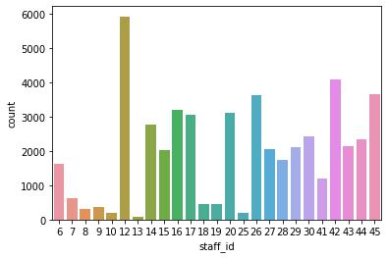

After seeing the countplot of staff_if , we can easily say that staff_id 12 is very often among all , so we can conclide that the staff having id 12 might be very loyal to work or is having much pressure to work in perticular time frame.
In [9]: sns.countplot(df['instore_yn'])

Out[9]: <AxesSubplot:xlabel='instore_yn', ylabel='count'>
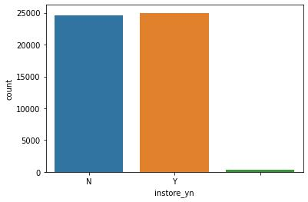

Here Instore_yn has majorly two values Y and N. and it is having approximately same value count of Y and N , so it is balanced.
In [10]: sns.countplot(df['promo_item_yn'])

Out[10]: <AxesSubplot:xlabel='promo_item_yn', ylabel='count'>
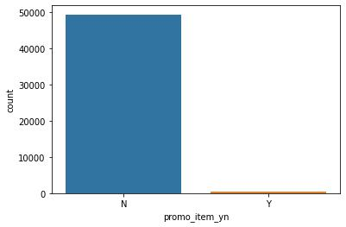

After plotting the count plot of promo_item_yn , we can clearly see that the dataset is imbalanced , so it will be better if we remove the column

In [11]: df=df.drop(columns=['promo_item_yn'])
In [12]: df.head()

Out[12]:

 | transaction_id | transaction_date | transaction_time | sales_outlet_id | staff_id | customer_id instore_yn order |  |  | line_item_id | product_id | quantity line
0 | 7 | 2019-04-01 | 12:04:43 | 3 | 12 | 558 | N | 1 | 1 | 52 | 1
1 | 11 | 2019-04-01 | 15:54:39 | 3 | 17 | 781 | N | 1 | 1 | 27 | 2
2 | 19 | 2019-04-01 | 14:34:59 | 3 | 17 | 788 | Y | 1 | 1 | 46 | 2
3 | 32 | 2019-04-01 | 16:06:04 | 3 | 12 | 683 | N | 1 | 1 | 23 | 2
4 | 33 | 2019-04-01 | 19:18:37 | 3 | 17 | 99 | Y | 1 | 1 | 34 | 1

In [13]: df['order'].value_counts().plot(kind='pie',autopct='%.2f')

Out[13]: <AxesSubplot:ylabel='order'>
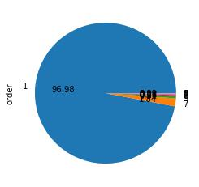

After seeing the pie-chart we can say that the order 1 is most frequent amongst all. and it is also imbalanced so we will remove the column here.

In [14]: df = df.drop(columns=['order'])
In [15]: df.head()

Out[15]:

 |  |  | transaction_id | transaction_date | transaction_time | sales_outlet_id | staff_id | customer_id instore_yn |  | line_item_id | product_id | quantity line_item_a
 | 0 |  | 7 | 2019-04-01 | 12:04:43 | 3 | 12 | 558 | N | 1 | 52 | 1
 | 1 |  | 11 | 2019-04-01 | 15:54:39 | 3 | 17 | 781 | N | 1 | 27 | 2
 | 2 |  | 19 | 2019-04-01 | 14:34:59 | 3 | 17 | 788 | Y | 1 | 46 | 2
 | 3 |  | 32 | 2019-04-01 | 16:06:04 | 3 | 12 | 683 | N | 1 | 23 | 2
 | 4 |  | 33 | 2019-04-01 | 19:18:37 | 3 | 17 | 99 | Y | 1 | 34 | 1

In [16]: import matplotlib.pyplot as plt

Plotting Histograms for columns in our dataset.

In [17]: plt.hist(df['unit_price'],bins=5)

Out[17]: (array([48970., 539., 235., 83., 67.]),

array([ 0.8 , 9.64, 18.48, 27.32, 36.16, 45. ]),

<BarContainer object of 5 artists>)
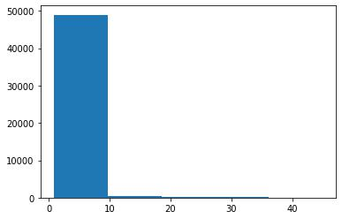
In [18]: df['product_id'].unique()

Out[18]: array([52, 27, 46, 23, 34, 32, 49, 60, 51, 35, 47, 25, 48, 53, 40, 37, 41, 38, 50, 59, 28, 77, 55, 54, 45, 79, 43, 61, 58, 42, 31, 39, 22, 76, 29, 33, 26, 30, 56, 74, 24, 71, 36, 69, 57, 70, 44, 78, 75, 73, 72, 87, 9, 84, 12, 6, 64, 63, 13, 65, 2, 7, 18, 20, 19, 10, 8, 15, 21, 4, 1, 17, 14, 82, 16, 3, 5, 81, 83, 11], dtype=int64)

In [19]: plt.hist(df['product_id'],bins=5)

Out[19]: (array([ 988., 13318., 16150., 10923., 8515.]),

array([ 1. , 18.2, 35.4, 52.6, 69.8, 87. ]),

<BarContainer object of 5 artists>)
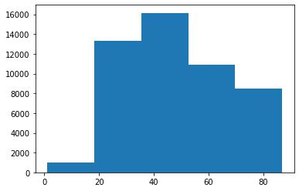

7. Bi-variate analysis on our dataset.
In [20]: sns.scatterplot(df['product_id'],df['unit_price'])

Out[20]: <AxesSubplot:xlabel='product_id', ylabel='unit_price'>
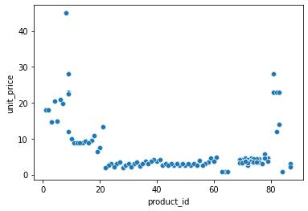

So here in the scatterplot of product_id vs unit_price we can see that products having id between 0 to 20 is of high to medium of price and products having id between 20 to 80 is of low price , it is so because it might possible that 0 to 20 product id is for some glossories and 20 to 80 product id id for some expensive products.

In [21]: sns.lineplot(df['unit_price'],df['product_id'])

Out[21]: <AxesSubplot:xlabel='unit_price', ylabel='product_id'>
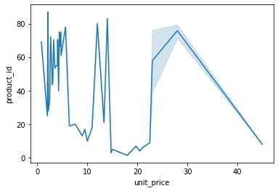
In [22]: sns.lineplot(df['transaction_date'],df['quantity'])

Out[22]: <AxesSubplot:xlabel='transaction_date', ylabel='quantity'>
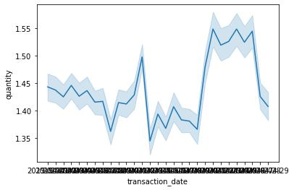

=============================================================
=

- CUSTOMER DATA ANALYSIS

1. Reading the data.

In [23]: df1=pd.read_csv('Data/customer.csv')

In [24]: df1.head()

Out[24]:

 | customer_id |  | home_store customer_first-name |  |  | customer_email customer_since |  | loyalty_card_number birthdate | gender | birth_year
0 |  | 1 | 3 |  | Kelly Key | Venus@adipiscing.edu | 2017-01-04 | 908-424-2890 1950-05-29 | M | 1950
1 |  | 2 | 3 | Clark Schroeder |  | Nora@fames.gov | 2017-01-07 | 032-732-6308 1950-07-30 | M | 1950
2 |  | 3 | 3 | Elvis Cardenas |  | Brianna@tellus.edu | 2017-01-10 | 459-375-9187 1950-09-30 | M | 1950
3 |  | 4 | 3 |  | Rafael Estes | Ina@non.gov | 2017-01-13 | 576-640-9226 1950-12-01 | M | 1950
4 |  | 5 | 3 |  | Colin Lynn | Dale@Integer.com | 2017-01-15 | 344-674-6569 1951-02-01 | M | 1951
In [25]: df1.info()
<class 'pandas.core.frame.DataFrame'>
RangeIndex: 2246 entries, |  |  |  | 0 to 2245
Data |  | columns (total 9 columns):
# |  | Column |  | Non-Null Count |  | Dtype
--- |  | ------ |  | -------------- |  | -----
0 |  | customer_id |  | 2246 | non-null | int64
1 |  | home_store |  | 2246 | non-null | int64
2 |  | customer_first-name |  | 2246 | non-null | object
3 |  | customer_email |  | 2246 | non-null | object
4 |  | customer_since |  | 2246 | non-null | object
5 |  | loyalty_card_number |  | 2246 | non-null | object
6 |  | birthdate |  | 2246 | non-null | object
7 |  | gender |  | 2246 | non-null | object
8 |  | birth_year |  | 2246 | non-null | int64
dtypes: int64(3), object(6)

memory usage: 158.0+ KB
In [26]: df1.describe()

Out[26]:

customer_id home_store birth_year

count 2246.000000 2246.000000 2246.000000

mean | 4285.902048 | 4.956812 | 1978.385574
std | 3088.088265 | 1.852562 | 14.925503
min | 1.000000 | 3.000000 | 1950.000000
25% | 562.250000 | 3.000000 | 1965.000000
50% | 5323.500000 | 5.000000 | 1981.000000
75% | 5884.750000 | 5.000000 | 1991.000000
max | 8501.000000 | 8.000000 | 2001.000000

2. Checking for correlations.

In [27]: df1.corr()

Out[27]:

customer_id home_store birth_year

customer_id 1.000000 0.948053 0.134341

home_store 0.948053 1.000000 0.084356

birth_year 0.134341 0.084356 1.000000

3. Performing Exploratory Data Analysis.
In [28]: sns.countplot(df1['birth_year'][:70])

Out[28]: <AxesSubplot:xlabel='birth_year', ylabel='count'>
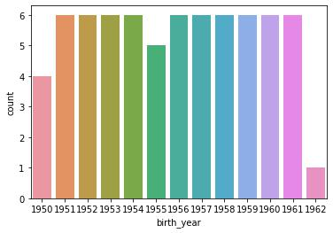
In [29]: sns.countplot(df1['gender'])

Out[29]: <AxesSubplot:xlabel='gender', ylabel='count'>
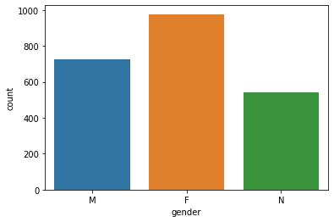

Here we can clearly see that the store has more Female customers as compared to Male.

In [30]: sns.distplot(df1[df1['customer_since']>'07-01-2017']['customer_id'],hist=True)

Out[30]: <AxesSubplot:xlabel='customer_id', ylabel='Density'>
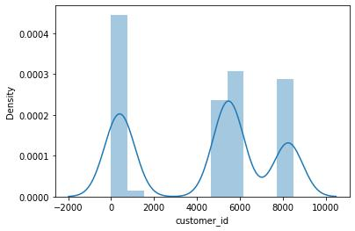

From the distribution plot we can see that more older customers has `higher customers id , which indicates that customers ids are provided sequently.
In [31]: sns.distplot(df1[df1['birth_year']>1950]['customer_id'],hist=True)

Out[31]: <AxesSubplot:xlabel='customer_id', ylabel='Density'>
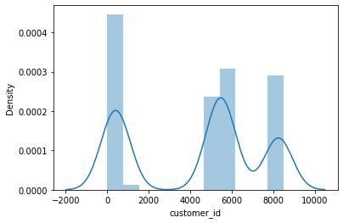
In [32]: sns.lineplot(df1['birth_year'],df1['customer_id'])

Out[32]: <AxesSubplot:xlabel='birth_year', ylabel='customer_id'>
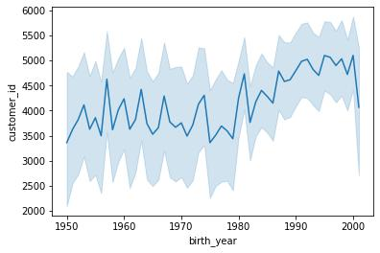

=============================================================

- PASTRY INVENTORY DATA ANALYSIS

1. Reading the data.

In [33]: df2=pd.read_csv('Data/pastry inventory.csv')

In [34]: df2.head()

Out[34]:

sales_outlet_id transaction_date product_id start_of_day quantity_sold waste % waste

0 | 3 | 4/1/2019 | 69 | 18 | 8 | 10 | 56%
1 | 3 | 4/1/2019 | 70 | 18 | 12 | 6 | 33%
2 | 3 | 4/1/2019 | 71 | 18 | 8 | 10 | 56%
3 | 3 | 4/1/2019 | 72 | 48 | 9 | 39 | 81%
4 | 3 | 4/1/2019 | 73 | 18 | 9 | 9 | 50%

In [35]: df2.tail()

Out[35]:

 | sales_outlet_id | transaction_date | product_id | start_of_day | quantity_sold | waste | % waste
302 | 8 | 4/27/2019 | 69 | 18 | 1 | 17 | 94%
303 | 8 | 4/27/2019 | 70 | 18 | 4 | 14 | 78%
304 | 8 | 4/27/2019 | 71 | 18 | 2 | 16 | 89%
305 | 8 | 4/27/2019 | 72 | 48 | 19 | 29 | 60%
306 | 8 | 4/27/2019 | 73 | 18 | 4 | 14 | 78%

In [36]: df2.info()
<class 'pandas.core.frame.DataFrame'>
RangeIndex: 307 entries, 0 |  |  | to 306
Data | columns (total 7 columns):
# | Column | Non-Null Count |  | Dtype
--- | ------ | -------------- |  | -----
0 | sales_outlet_id | 307 | non-null | int64
1 | transaction_date | 307 | non-null | object
2 | product_id | 307 | non-null | int64
3 | start_of_day | 307 | non-null | int64
4 | quantity_sold | 307 | non-null | int64
5 | waste | 307 | non-null | int64
6 | % waste | 307 | non-null | object
dtypes: int64(5), object(2)

memory usage: 16.9+ KB

In [37]: df2.describe()

Out[37]:

 | sales_outlet_id product_id start_of_day |  |  | quantity_sold | waste
count | 307.000000 | 307.000000 | 307.000000 | 307.000000 | 307.000000
mean | 5.394137 | 70.983713 | 24.058632 | 9.296417 | 14.657980
std | 2.049477 | 1.417582 | 12.063414 | 5.440115 | 11.202108
min | 3.000000 | 69.000000 | 18.000000 | 0.000000 | 0.000000
25% | 3.000000 | 70.000000 | 18.000000 | 6.000000 | 8.000000
50% | 5.000000 | 71.000000 | 18.000000 | 8.000000 | 11.000000
75% | 8.000000 | 72.000000 | 18.000000 | 11.000000 | 15.000000
max | 8.000000 | 73.000000 | 48.000000 | 32.000000 | 47.000000

In [38]: df2.corr()

Out[38]:

 | sales_outlet_id product_id |  | start_of_day | quantity_sold | waste
sales_outlet_id | 1.000000 | 0.013465 | -0.005696 | 0.120800 | -0.053893
product_id | 0.013465 | 1.000000 | 0.361235 | 0.134961 | 0.339001
start_of_day | -0.005696 | 0.361235 | 1.000000 | 0.393825 | 0.893224
quantity_sold | 0.120800 | 0.134961 | 0.393825 | 1.000000 | -0.043859
waste | -0.053893 | 0.339001 | 0.893224 | -0.043859 | 1.000000

2. Exploratory Data Analysis.
In [39]: sns.lineplot(df2['start_of_day'],df2['waste'])

Out[39]: <AxesSubplot:xlabel='start_of_day', ylabel='waste'>
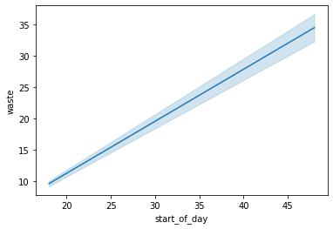

Here we can see from the lineplot that as start of the day increases , the waste is also increasing which is showing linear behaviour.
In [40]: sns.lineplot(df2['start_of_day'],df2['quantity_sold'])

Out[40]: <AxesSubplot:xlabel='start_of_day', ylabel='quantity_sold'>
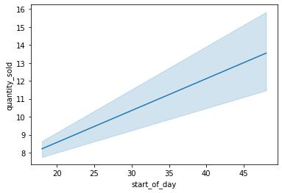

Here we can see from the lineplot that as start of the day increases , the waste is also increasing which is showing linear behaviour.

In [41]: sns.lineplot(df2['product_id'],df2['waste'])

Out[41]: <AxesSubplot:xlabel='product_id', ylabel='waste'>
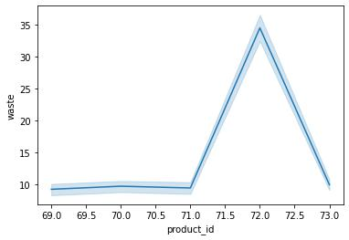
In [42]: sns.barplot(df2['% waste'],df2['product_id'])

Out[42]: <AxesSubplot:xlabel='% waste', ylabel='product_id'>
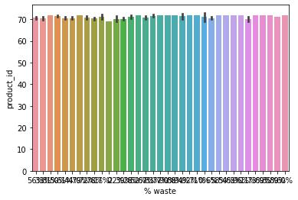

========================================================================================

- PRODUCT DATA ANALYSIS

1. Reading the dataset.

In [43]: df3=pd.read_csv('Data/product.csv')

In [44]: df3.head()

Out[44]:

product_id product_group product_category product_type product product_description unit_of_measure current_wholesale_price current_ret

0 |  | 1 | Whole
 |  | 1 | Bean/Teas
1 |  | 2 | Whole
 |  | 2 | Bean/Teas
2 |  | 3 | Whole
 |  | 3 | Bean/Teas
3 |  | 4 | Whole
 |  | 4 | Bean/Teas
4 |  | 5 | Whole
 |  | 5 | Bean/Teas

Coffee beans

Coffee beans

Coffee beans

Coffee beans

Coffee beans

Organic | Brazilian - | It's like Carnival in a
Organic | Brazilian - | cup. Clean and
Beans | Organic | cup. Clean and
Beans | Organic | smooth.
 | Our Old | Out packed blend of
House blend | Time | Out packed blend of
House blend | Time | beans that is
Beans | Diner | beans that is
Beans | Diner | reminiscent ...
 | Blend | reminiscent ...
Espresso | Espresso | Our house blend for a
Beans | Roast | good espresso shot.
Espresso | Primo | Our primium single
Espresso | Espresso | source of hand
Beans | Espresso | source of hand
Beans | Roast | roasted beans.
Gourmet | Columbian | A smooth cup of
Beans | Medium | coffee any time of
Beans | Roast | day.

12 oz | 14.40
12 oz | 14.40
1 lb | 11.80
1 lb | 16.36
1 lb | 12.00


In [45]: sns.countplot(df3['product_type'])

Out[45]: <AxesSubplot:xlabel='product_type', ylabel='count'>
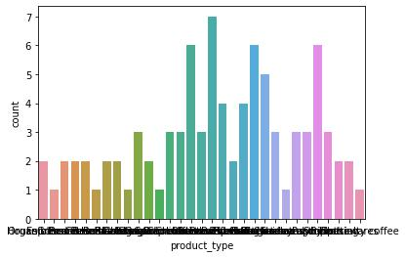
In [46]: df3['product_type'].value_counts()

Out[46]: Barista Espresso | 7
Gourmet brewed coffee | 6
Scone | 6
Brewed Chai tea | 6
Hot chocolate | 5
Brewed herbal tea | 4
Brewed Black tea | 4
Pastry | 3
Drip coffee | 3
Premium brewed coffee | 3
Chai tea | 3
Seasonal drink | 3
Regular syrup | 3
Biscotti | 3
Organic brewed coffee | 3
Organic Beans | 2
Drinking Chocolate | 2
Housewares | 2
Espresso Beans | 2
Premium Beans | 2
Gourmet Beans | 2
Brewed Green tea | 2
Herbal tea | 2
Black tea | 2
Clothing | 2
Sugar free syrup | 1
Green tea | 1
Green beans | 1
House blend Beans | 1
Organic Chocolate | 1
Specialty coffee | 1
Name: product_type, dtype: int64
In [47]: sns.lineplot(df3['current_retail_price'],df3['product_id'])

Out[47]: <AxesSubplot:xlabel='current_retail_price', ylabel='product_id'>
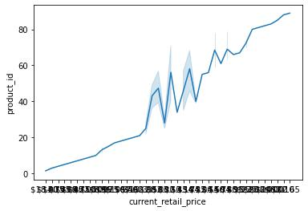
In [48]: sns.countplot(df3['promo_yn'])

Out[48]: <AxesSubplot:xlabel='promo_yn', ylabel='count'>
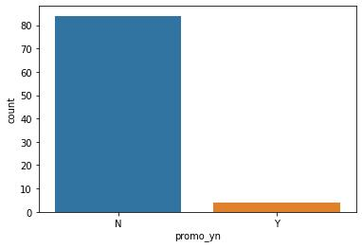

Here from the count plot we can conclude that there is not any promo available for most of the products available in the shop.

In [49]: sns.countplot(df3['new_product_yn'])

Out[49]: <AxesSubplot:xlabel='new_product_yn', ylabel='count'>
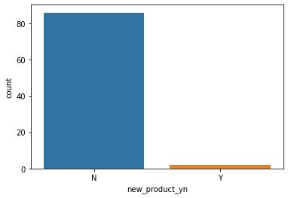

Here from the count plot we can conclude that most of the products available in the shop are not new , they are old products.
In [50]: sns.lineplot(df3['current_retail_price'],df3['current_wholesale_price'])

Out[50]: <AxesSubplot:xlabel='current_retail_price', ylabel='current_wholesale_price'>
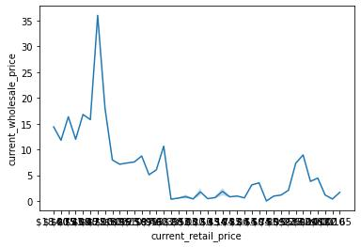

- PANDAS PROFILING

Pandas profiling is a library which is very useful for exploratory data analysis and using which we can automate some part of our exploratory data analysis on our dataset.

In [51]: from pandas_profiling import ProfileReport

In [52]: prof = ProfileReport(df)

prof.to_file(output_file='sales receipts.html')
\

In [53]:
prof = ProfileReport(df1)

prof.to_file(output_file='customers.html')

In [54]: prof = ProfileReport(df2)

prof.to_file(output_file='pastry inventory.html')

In [55]: prof = ProfileReport(df3)

prof.to_file(output_file='product.html')

In [ ]: ​

GITHUB LINK : https://github.com/ParthShukla211/FEYNN-LABS_PROJECT---1

